Catch the ball

Overview

“catch the ball” is a basic 2d arcade game to demonstrate the overall flow of a game using python and simpleGE

The Game premise: the game consists of bike png, bike which appear near the bottom of the gameplay screen with a background image of the bg.png . the user can move bike from left to right with the corresponding arrow keys. A series of ball will be dropping from the top of the screen within the pg.png each ball will fall from a different x position, and at a different speed between 3 and 8 pixels per frame straight down. If bike touches a ball, a positive sound effect is played, and the player score increased if a ball leave the bottom screen, or collide with the bike, it reset to a new random position at the top of the screen

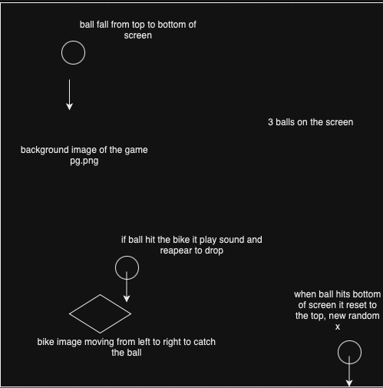

Algorithm:

1. Intialize the game

Set up the game background

Load images and sounds needed for the bike, ball, background and sound

1. Create Game Objects:

Initialize the bike object

1. Game loop

Check for user input (left or right) and move the bike accordingly

Update the position of the ball (move up and down)

Check for collision between bike and any balls

Pseudocode:

Initialize pygame

Load “soccerBall>png”, “sound.mp3”, “bike.png”, “bg.png”

Class Ball:

Initialize (scene):

Set image to “soccerBall.png”

Set size to (25, 25)

Call reset()

Load sound “sound.mp3”

Reset ():

Position y at 10

Position x randomly across the width

Set downward movement speed randomly btw 3 and 8

Move():

Update y by downward movement speed if ball is below the screen: call reset()

Class Bike:

Initialize (scene):

Set image to “bike.png”

Set size to (60, 80)

Position at (300, 800)

Set moveSpeed

Move():

If left key pressed:

Move left by moveSpeed

If rright key pressed:

Move right by moveSpeed

Class Game:

Initialize()

Set background to “pg.png”

Create a Bike object

Create a list a Ball objects

GameLoop():

While game is running:

Handle input

Move bike based on input

Move eqach ball

Check for collisions between bike and balls

If collision, play sound and reset ball

Redraw background, bike, and balls

Function Main():

Initialize pygame

Create a Game object

Start game loop

Main()